**Practical-3**

**AIM: Implement Huffman Code(HC) to generate binary code when symbol and probabilities are given.**

**CODE:**

import heapq

class node:

def __init__(self, freq, symbol, left=None, right=None):

self.freq = freq

self.symbol = symbol

self.left = left

self.right = right

self.huff = ''

def __lt__(self, nxt):

return self.freq < nxt.freq

def printNodes(node, val=''):

newVal = val + str(node.huff)

if(node.left):

printNodes(node.left, newVal)

if(node.right):

printNodes(node.right, newVal)

if(not node.left and not node.right):

print(f"{node.symbol} -> {newVal}")

chars = ['y', 'a', 's', 'h', 'p', 't']

freq = [ 25, 6, 50, 20, 10, 95]

nodes = []

for x in range(len(chars)):

heapq.heappush(nodes, node(freq[x], chars[x]))

while len(nodes) > 1:

left = heapq.heappop(nodes)

right = heapq.heappop(nodes)

left.huff = 0

right.huff = 1

newNode = node(left.freq+right.freq, left.symbol+right.symbol, left, right)

heapq.heappush(nodes, newNode)

printNodes(nodes[0])

**OUTPUT:**

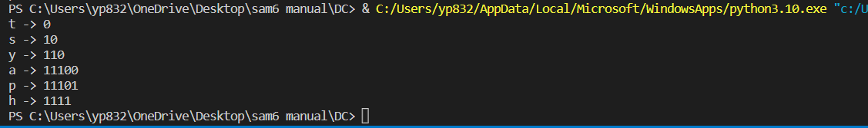

**Practical-4**

**AIM: Implement Huffman code which can compress given file and**

**decompress compressed file.**

**CODE:**

class Nodes:

def __init__(self, probability, symbol, left = None, right = None):

self.probability = probability

self.symbol = symbol

self.left = left

self.right = right

self.code = ''

def CalculateProbability(the_data):

the_symbols = dict()

for item in the_data:

if the_symbols.get(item) == None:

the_symbols[item] = 1

else:

the_symbols[item] += 1

return the_symbols

the_codes = dict()

def CalculateCodes(node, value = ''):

newValue = value + str(node.code)

if(node.left):

CalculateCodes(node.left, newValue)

if(node.right):

CalculateCodes(node.right, newValue)

if(not node.left and not node.right):

the_codes[node.symbol] = newValue

return the_codes

def OutputEncoded(the_data, coding):

encodingOutput = []

for element in the_data:

encodingOutput.append(coding[element])

the_string = ''.join([str(item) for item in encodingOutput])

return the_string

def TotalGain(the_data, coding):

beforeCompression = len(the_data) * 8

afterCompression = 0

the_symbols = coding.keys()

for symbol in the_symbols:

the_count = the_data.count(symbol)

afterCompression += the_count * len(coding[symbol])

print("Space usage before compression (in bits):", beforeCompression)

print("Space usage after compression (in bits):", afterCompression)

def HuffmanEncoding(the_data):

symbolWithProbs = CalculateProbability(the_data)

the_symbols = symbolWithProbs.keys()

the_probabilities = symbolWithProbs.values()

print("symbols: ", the_symbols)

print("probabilities: ", the_probabilities)

the_nodes = []

for symbol in the_symbols:

the_nodes.append(Nodes(symbolWithProbs.get(symbol), symbol))

while len(the_nodes) > 1:

the_nodes = sorted(the_nodes, key = lambda x: x.probability)

right = the_nodes[0]

left = the_nodes[1]

left.code = 0

right.code = 1

newNode = Nodes(left.probability + right.probability, left.symbol + right.symbol, left, right)

the_nodes.remove(left)

the_nodes.remove(right)

the_nodes.append(newNode)

huffmanEncoding = CalculateCodes(the_nodes[0])

print("symbols with codes", huffmanEncoding)

TotalGain(the_data, huffmanEncoding)

encodedOutput = OutputEncoded(the_data,huffmanEncoding)

return encodedOutput, the_nodes[0]

def HuffmanDecoding(encodedData, huffmanTree):

treeHead = huffmanTree

decodedOutput = []

for x in encodedData:

if x == '1':

huffmanTree = huffmanTree.right

elif x == '0':

huffmanTree = huffmanTree.left

try:

if huffmanTree.left.symbol == None and huffmanTree.right.symbol == None:

pass

except AttributeError:

decodedOutput.append(huffmanTree.symbol)

huffmanTree = treeHead

string = ''.join([str(item) for item in decodedOutput])

return string

the_data = input("enter the string")

print(the_data)

encoding, the_tree = HuffmanEncoding(the_data)

print("Encoded output", encoding)

print("Decoded Output", HuffmanDecoding(encoding, the_tree))

**OUTPUT:**

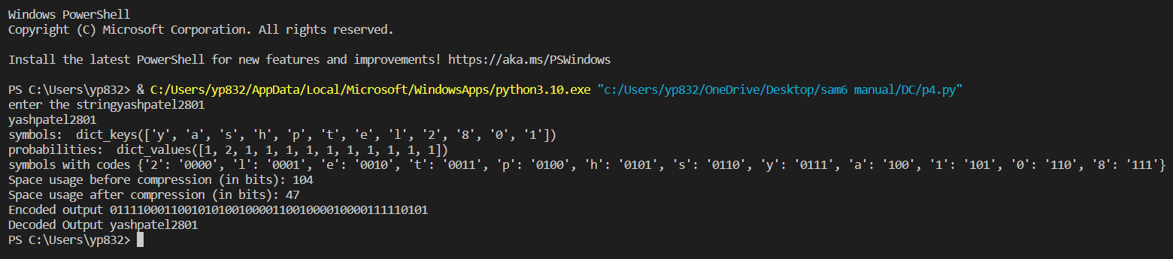

**Practical-5**

**AIM: Implement adaptive Huffman program to compress decompressed file.**

**CODE:**

class Nodes:

def __init__(self, probability, symbol, left = None, right = None):

self.probability = probability

self.symbol = symbol

self.left = left

self.right = right

self.code = ''

def CalculateProbability(the_data):

the_symbols = dict()

for item in the_data:

if the_symbols.get(item) == None:

the_symbols[item] = 1

else:

the_symbols[item] += 1

return the_symbols

the_codes = dict()

def CalculateCodes(node, value = ''):

newValue = value + str(node.code)

if(node.left):

CalculateCodes(node.left, newValue)

if(node.right):

CalculateCodes(node.right, newValue)

if(not node.left and not node.right):

the_codes[node.symbol] = newValue

return the_codes

def OutputEncoded(the_data, coding):

encodingOutput = []

for element in the_data:

encodingOutput.append(coding[element])

the_string = ''.join([str(item) for item in encodingOutput])

return the_string

def TotalGain(the_data, coding):

beforeCompression = len(the_data) * 8

afterCompression = 0

the_symbols = coding.keys()

for symbol in the_symbols:

the_count = the_data.count(symbol)

afterCompression += the_count * len(coding[symbol])

print("Space usage before compression (in bits):", beforeCompression)

print("Space usage after compression (in bits):", afterCompression)

def HuffmanEncoding(the_data):

symbolWithProbs = CalculateProbability(the_data)

the_symbols = symbolWithProbs.keys()

the_probabilities = symbolWithProbs.values()

print("symbols: ", the_symbols)

print("probabilities: ", the_probabilities)

the_nodes = []

for symbol in the_symbols:

the_nodes.append(Nodes(symbolWithProbs.get(symbol), symbol))

while len(the_nodes) > 1:

the_nodes = sorted(the_nodes, key = lambda x: x.probability)

right = the_nodes[0]

left = the_nodes[1]

left.code = 0

right.code = 1

newNode = Nodes(left.probability + right.probability, left.symbol + right.symbol, left, right)

the_nodes.remove(left)

the_nodes.remove(right)

the_nodes.append(newNode)

huffmanEncoding = CalculateCodes(the_nodes[0])

print("symbols with codes", huffmanEncoding)

TotalGain(the_data, huffmanEncoding)

encodedOutput = OutputEncoded(the_data,huffmanEncoding)

return encodedOutput, the_nodes[0]

def HuffmanDecoding(encodedData, huffmanTree):

treeHead = huffmanTree

decodedOutput = []

for x in encodedData:

if x == '1':

huffmanTree = huffmanTree.right

elif x == '0':

huffmanTree = huffmanTree.left

try:

if huffmanTree.left.symbol == None and huffmanTree.right.symbol == None:

pass

except AttributeError:

decodedOutput.append(huffmanTree.symbol)

huffmanTree = treeHead

string = ''.join([str(item) for item in decodedOutput])

return string

the_data = input("enter the string")

print(the_data)

encoding, the_tree = HuffmanEncoding(the_data)

print("Encoded output", encoding)

print("Decoded Output", HuffmanDecoding(encoding, the_tree))

**OUTPUT:**



**Practical-2**

**AIM: Write a program to generate binary code in case of arithmetic coding.**

**CODE:**

#include<iostream>

#include<unordered_map>

#include<vector>

using namespace std;

struct node{

double prob, range_from, range_to;};

double encoding(unordered_map<char, node> arr, string s){

cout<<"\nEncoding\n";

double low_v=0.0, high_v=1.0, diff= 1.0;

cout<<"Symbol\tLow_v\tHigh_v\tdiff\n";

for(int i=0; i<s.size(); i++){

high_v= low_v+ diff* arr[s[i]].range_to;

low_v= low_v+ diff* arr[s[i]].range_from;

diff= high_v- low_v;

cout<<s[i]<<"\t"<<low_v<<"\t"<<high_v<<"\t"<<diff<<endl; }

return low_v;}

string decoding(unordered_map<char, node> arr, double code_word, int len){

cout<<"\nDecoding: \n";

char ch;

string text= "";

int j=0;

unordered_map<char, node>:: iterator it;

cout<<"Code\tOutput\tRange_from\tRange_to\n";

while(j<len){

cout<<code_word<<"\t";

for(it= arr.begin(); it!=arr.end(); it++){

char i= (*it).first;

if(arr[i].range_from<= code_word && code_word< arr[i].range_to){

ch= i;

code_word= (code_word-arr[i].range_from)/(arr[i].range_to- arr[i].range_from);

break;

}}

cout<<ch<<"\t"<<arr[ch].range_from<<"\t\t"<<arr[ch].range_to<<endl;

text+= ch;

j++;

}

return text;

}

int main(){

int n;

cout<<"Enter number of characters: ";

cin>>n;

unordered_map<char, node> arr;

vector<char> ar;

double range_from= 0;

cout<<"Enter probability of each character:\n";

for(int i=0; i<n; i++){

char ch;

cin>>ch;

ar.push_back(ch);

cin>>arr[ch].prob;

arr[ch].range_from= range_from;

arr[ch].range_to= range_from+ arr[ch].prob;

range_from= arr[ch].range_to;

}

cout<<"Symbol\tProbability\tRange_from\tRange_to\n";

cout<<"----------------------------------------------------\n";

for(int i=0; i<ar.size(); i++){

char ch= ar[i];

cout<<ch<<"\t"<<arr[ch].prob<<"\t\t"<<arr[ch].range_from<<"\t\t"<<arr[ch].range_to<<endl;

}

cout<<endl;

string s;

cout<<"Enter text: ";

cin>>s;

double code_word= encoding(arr, s);

cout<<"Code word for "<<s<<" is: "<<code_word<<endl;

string text= decoding(arr, code_word, s.size());

cout<<"Text for "<<code_word<<" is: "<<text<<endl;

}

**OUTPUT:**

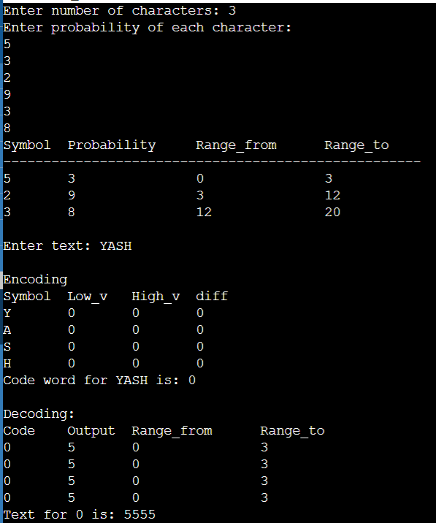

**Practical-6**

**AIM: Write a program to Implement LZ77 algorithm.**

**CODE:**

def compress(data):

compressed_data = []

search_buffer = ""

lookahead_buffer = ""

search_buffer_size = 10

lookahead_buffer_size = 5

for i in range(len(data)):

lookahead_buffer += data[i]

if len(lookahead_buffer) == lookahead_buffer_size or i == len(data) - 1:

best_match_length = 0

best_match_position = 0

for j in range(len(search_buffer)):

match_length = 0

for k in range(len(lookahead_buffer)):

if search_buffer[j+k] != lookahead_buffer[k]:

break

match_length += 1

if match_length > best_match_length:

best_match_length = match_length

best_match_position = j

compressed_data.append((best_match_position, best_match_length, lookahead_buffer[best_match_length:]))

search_buffer += lookahead_buffer

search_buffer = search_buffer[-search_buffer_size:]

lookahead_buffer = ""

return compressed_data

def decompress(compressed_data):

decompressed_data = ""

search_buffer = ""

for i in range(len(compressed_data)):

match_position, match_length, c = compressed_data[i]

decompressed_data += search_buffer[match_position:match_position+match_length]

search_buffer += c

decompressed_data += c

return decompressed_data

data = "ABCDEFABCRDEDDFHTFDDD"

compressed_data = compress(data)

print(compressed_data)

decompressed_data = decompress(compressed_data)

print(decompressed_data)

**OUTPUT:**

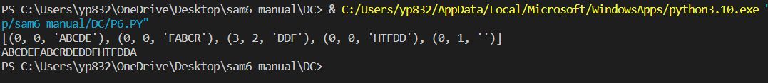

**Practical-7**

**AIM: Write a program to Implement LZW algorithm.**

**CODE:**

def lzw_compress(text):

dictionary = {chr(i): i for i in range(256)}

next_index = 256

result = []

i = 0

while i < len(text):

j = 1

while j <= len(text) - i:

if text[i:i+j] in dictionary:

j += 1

else:

break

index = dictionary.get(text[i:i+j-1], None)

if index is None:

index = ord(text[i])

result.append(index)

dictionary[text[i:i+j]] = next_index

next_index += 1

i += j - 1

return result

def lzw_decompress(compressed):

dictionary = {i: chr(i) for i in range(256)}

next_index = 256

result = ""

string = chr(compressed[0])

result += string

for index in compressed[1:]:

if index in dictionary:

next_string = dictionary[index]

elif index == next_index:

next_string = string + string[0]

else:

raise ValueError("Compressed data is corrupted")

result += next_string

dictionary[next_index] = string + next_string[0]

next_index += 1

string = next_string

return result

text = "MISSISSIPI"

compressed = lzw_compress(text)

print("\nCompressed:")

print(compressed)

print("\nDecompressed:")

print(lzw_decompress(compressed))

**OUTPUT:**

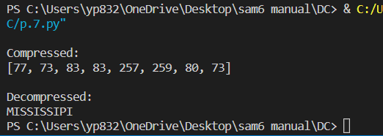

**Practical-8**

**AIM: Write a program to Implement LZ78 algorithm.**

**CODE:**

def lz78_compress(text):

dictionary = {char: idx for idx, char in enumerate(set(text))}

result = []

i = 0

while i < len(text):

j = i + 1

while j <= len(text) and text[i:j] in dictionary:

j += 1

if j > len(text):

break

dictionary[text[i:j]] = len(dictionary) + 1

result.append((dictionary[text[i:j - 1]], text[j - 1]))

i = j

return result

def lz78_decompress(compressed):

dictionary = {idx: char for idx, char in enumerate(set(text))}

result = ""

for code, next_char in compressed:

if code in dictionary:

result += dictionary[code] + next_char

dictionary[len(dictionary) + 1] = dictionary[code] + next_char

else:

result += next_char

dictionary[len(dictionary) + 1] = next_char

return result

text = "MISSISSIPI"

compressed = lz78_compress(text)

print("\nCompressed:")

print(compressed)

print("\nDecompressed:")

print(lz78_decompress(compressed))

**OUTPUT:**

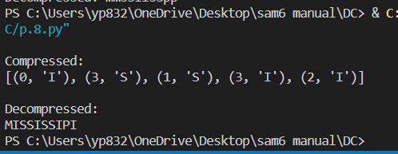

**Practical-1**

**AIM: Write a program to Implement BWT algorithm.**

**CODE:**

a = input("Enter a string:")

words = list(a)

list = []

for i in range(len(words)):

word = a[-1] + a[:-1]

new = ''.join(word)

a = new

list.append(new)

i += 1

print(list)

sort = sorted(list)

print(sort)

for i in range(len(words)):

element = sort[i]

last = element[- 1]

i = i + 1

print(last)

**OUTPUT:**

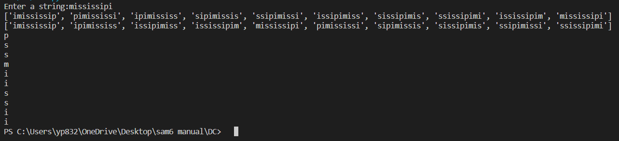

**Practical-10**

**AIM: Write a program to Implement MTF algorithm.**

**CODE:**

def search(input_char, char_list):

for i in range(len(char_list)):

if char_list[i] == input_char:

return i

def move_to_front(curr_index, char_list):

char = char_list.pop(curr_index)

char_list.insert(0, char)

def mtf_encode(input_text, char_list):

output_arr = []

for char in input_text:

output_arr.append(search(char, char_list))

move_to_front(output_arr[-1], char_list)

return output_arr

if __name__ == '__main__':

input_text = "panama"

char_list = list("abcdefghijklmnopqrstuvwxyz")

print(f"Input text: {input_text}")

print("Move to Front Transform:", end=" ")

mtf_transform = mtf_encode(input_text, char_list)

print(mtf_transform)

**OUTPUT:**

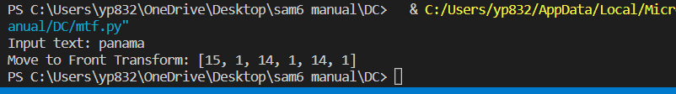

**Practical-9**

**AIM: Write a program which performs JPEG compression, process step bystep**

**for given 8x8 block and decompression also.**

**CODE:**

from heapq import heappush, heappop, heapify

from collections import defaultdict

import numpy as np

def huffman_encoding(arr):

arr_list = arr.flatten().tolist()

freq = defaultdict(int)

for symbol in arr_list:

freq[symbol] += 1

heap = [[wt, [sym, ""]] for sym, wt in freq.items()]

heapify(heap)

while len(heap) > 1:

lo = heappop(heap)

hi = heappop(heap)

for pair in lo[1:]:

pair[1] = '0' + pair[1]

for pair in hi[1:]:

pair[1] = '1' + pair[1]

heappush(heap, [lo[0] + hi[0]] + lo[1:] + hi[1:])

huffman_dict = dict(heappop(heap)[1:])

encoded_list = [huffman_dict[symbol] for symbol in arr_list]

encoded_str = "".join(encoded_list)

return encoded_str, huffman_dict

def huffman_decoding(encoded_str, huffman_dict):

reverse_dict = {v: k for k, v in huffman_dict.items()}

code = ""

decoded_list = []

for bit in encoded_str:

code += bit

if code in reverse_dict:

symbol = reverse_dict[code]

decoded_list.append(symbol)

code = ""

decoded_arr = np.array(decoded_list).reshape((8,8))

return decoded_arr

arr = np.array([[52, 55, 61, 66, 70, 61, 64, 73],

[63, 59, 55, 90, 109, 85, 69, 72],

[62, 59, 68, 113, 144, 104, 66, 73],

[63, 58, 71, 122, 154, 106, 70, 69],

[67, 61, 68, 104, 126, 88, 68, 70],

[79, 65, 60, 70, 77, 68, 58, 75],

[85, 71, 64, 59, 55, 61, 65, 83],

[87, 79, 69, 68, 65, 76, 78, 94]])

encoded_str, huffman_dict = huffman_encoding(arr)

print("Encoded String:\n", encoded_str)

print("Huffman Dictionary:\n", huffman_dict)

decoded_arr = huffman_decoding(encoded_str, huffman_dict)

print("Decoded Array:\n", decoded_arr)

**OUTPUT:**

